**SUMMER TRAINING PROJECT REPORT**

(TERM JUNE-JULY 2025)

**DAILY PLANNER: PERSONAL PRODUCTIVITY AND SCHEDULE MANAGEMENT SYSTEM**

**Submitted by:**

# Name: Srijan Kumar Pandey

Registration number: **12316351**

Course Code: **CSE 443**

Under the guidance of:

# MUKESH SHARMA SIR



**SCHOOL OF COMPUTERSCIENCEAND ENGINEERING**

**LOVELY PROFESSIONAL UNIVERSITY ACKNOWLEDGEMENT**

I would like to express my sincere gratitude to my mentor **Mr. Mukesh Sharma** for his continuous guidance, support, and encouragement throughout this summer training program. His expertise in Data Structures and Algorithms has been instrumental in shaping my understanding of complex programming concepts.

I am also thankful to **School of Computer Science and Engineering – Lovely Professional University** for providing me with this opportunity to enhance my technical skills through hands-on project development. The training program has significantly contributed to my academic and professional growth.

**Srijan kumar pandey**

Registration Number: **12316351**

## TABLE OF CONTENTS

**CHAPTER 1: INTRODUCTION .........................................................................................** 1

* OVERVIEW OF TRAINING DOMAIN ....................................................................... 1
* OBJECTIVE OF THE PROJECT .................................................................................. 1

**CHAPTER 2: TRAINING OVERVIEW .............................................................................** 2

* TOOLS & TECHNOLOGIES USED .............................................................................. 2
* AREAS COVERED DURING TRAINING .................................................................... 2
* DAILY/WEEKLY WORK SUMMARY ......................................................................... 3

**CHAPTER 3: PROJECT DETAILS ....................................................................................** 4

* TITLE OF THE PROJECT ............................................................................................ 4
* PROBLEM DEFINITION .............................................................................................. 4
* SCOPE AND OBJECTIVES .......................................................................................... 4
* SYSTEM REQUIREMENTS ......................................................................................... 5
* ARCHITECTURE DIAGRAM ..................................................................................... 5
* DATA FLOW / UML DIAGRAMS ............................................................................... 6

**CHAPTER 4: IMPLEMENTATION ...................................................................................** 7

* TOOLS USED ............................................................................................................... 7
* METHODOLOGY ........................................................................................................ 7
* MODULES / SCREENSHOTS ..................................................................................... 8
* CODE SNIPPETS ......................................................................................................... 9

**CHAPTER 5: RESULTS AND DISCUSSION ....................................................................** 11

* OUTPUT / REPORT ..................................................................................................... 11
* CHALLENGES FACED ............................................................................................... 12
* TECHNICAL LEARNINGS ......................................................................................... 12

**CHAPTER 6: CONCLUSION .............................................................................................** 14

* SUMMARY ................................................................................................................... 14

## CHAPTER 1: INTRODUCTION

1. **OVERVIEW OF TRAINING DOMAIN**

The summer training program focused on **Data Structures and Algorithms (DSA)** with practical implementation through web development technologies. The training domain encompassed fundamental and advanced DSA concepts including linear data structures (Arrays, Linked Lists, Stacks, Queues), non-linear data structures (Trees, Graphs), and algorithmic paradigms (Searching, Sorting, Dynamic Programming).

The program emphasized the practical application of DSA concepts in real-world software development, particularly in creating efficient and scalable web applications.

The curriculum was designed to bridge the gap between theoretical knowledge of data structures and their practical implementation in software projects. Special emphasis was placed on understanding time and space complexity analysis, algorithm optimization, and choosing appropriate data structures for specific problem scenarios.

1. **OBJECTIVE OF THE PROJECT**

The primary objectives of this summer training project were:

* + **Technical Skill Development**: To gain proficiency in Data Structures and Algorithms through practical implementation and real-world application scenarios.
  + **System Design Understanding**: To understand the principles of system architecture, database design, and user interface development for large- scale applications.
  + **Problem-Solving Enhancement**: To enhance analytical thinking and problem-solving skills through the implementation of complex algorithms and data structures.
  + **Project Management**: To learn project planning, version control, and collaborative development practices using industry-standard tools.

## CHAPTER 2: TRAINING OVERVIEW

1. **TOOLS AND TECHNOLOGIES USED**

* + - * + Visual Studio Code as primary IDE o HTML CSS for front end
        + Java script for backend

1. **AREAS COVERED DURING TRAINING**

* + - 1. **Data Structures Fundamentals:**

o Linear data structures implementation and optimization

o Non-linear data structures for complex data relationships

o Memory management and space complexity analysis

o Data structure selection criteria for specific use cases

* + - 1. **Algorithm Design:**

o Searching and sorting algorithm implementation

o Time complexity analysis and Big O notation

o Algorithm optimization techniques

o Problem-solving methodologies

**c) Data Structure Implementation:**

* + **Hash Table:** Used for O (1) voter lookup and authenticationo **Queue**: FIFO processing of vote submissions for fair handling o **Merkle Tree**: Binary tree structure for vote integrity verification o **Array**: Storage of processed votes and candidate information **(iii)DAILY/WEEKLY WORK SUMMARY**

**Week 1: Foundation Building**

o Arrays & Objects: Implementation of dynamic data storage for tasks and daily entries.

o Basic Algorithms: Searching and sorting for task prioritization and display.

o HTML/CSS Fundamentals: Structuring the planner interface and applying styles.

**Week 2: Core Functionality Development**

o Event Handling: Implementing user interactions for adding/deleting tasks and fixed activities.

o Date Management: Handling date selection and dynamic display of daily information.

o Local Storage Integration: Implementing data persistence using browser's local storage.

**Week 3: Schedule Generation Logic**

o Time Slot Management: Developing algorithms to manage and allocate available time slots.

o Task Prioritization: Implementing logic to prioritize and fit tasks into the daily schedule.

o Dynamic UI Updates: Ensuring the schedule timeline updates in real-time.

**Week 4: Enhancing User Experience**

o Motivational Content: Integrating dynamic motivational quotes.

o Notes & Mood Tracking: Implementing features for daily notes and mood selection.

o Responsive Design: Adapting the layout for various screen sizes (mobile, tablet, desktop).

**Week 5: Statistics and Refinement**

o Productivity Metrics: Developing calculations for daily statistics like total task time, free time, and productivity.

o UI/UX Polish: Refining visual elements, animations, and overall user interface.

o Code Optimization: Reviewing and optimizing JavaScript for performance.

**Week 6: Project Integration and Testing**

o Module Integration: Combining all features into a cohesive daily planner application.

o Testing: Thorough testing of all functionalities, including data persistence and responsiveness.

## CHAPTER 3: PROJECT DETAILS

1. **TITLE OF THE PROJECT**

“Daily Planner: Personal Productivity and Schedule Management System”

1. **PROBLEM DEFINITION**

Many individuals struggle with organizing their daily activities, managing time effectively, and maintaining motivation. Common challenges include task overload, difficulty prioritizing, forgetting appointments, and a lack of clear overview of their day. Traditional paper planners can be cumbersome, and existing digital solutions may lack flexibility or a personalized touch.

1. **KEY PROBLEMS ADDRESSED:**

**Disorganization:** Helping users consolidate tasks, appointments, and notes in one place.

**Time Management:** Providing tools to allocate time for fixed activities and flexible tasks.

**Prioritization:** Enabling users to prioritize tasks and ensure important items are addressed.

Motivation & Well-being: Incorporating features like motivational quotes and mood tracking to support mental well-being.

**Accessibility:** Creating an intuitive and responsive interface accessible across devices.

**Data Persistence:** Ensuring daily plans, notes, and mood data are saved and retrievable.

**(iv) SCOPE AND OBJECTIVES**

**Project Scope:** The Daily Planner platform provides a comprehensive web-based solution for personal productivity, encompassing daily task management, fixed schedule integration, notes, mood tracking, and real-time schedule visualization. The system leverages efficient data structures and algorithms to ensure optimal performance and a smooth user experience.

1. **Streamlined Task Management**: Implement intuitive interfaces for adding, prioritizing, and managing daily tasks.
2. **Flexible Scheduling:** Allow users to define fixed activities and dynamically allocate flexible tasks into available time slots.
3. **Data Persistence:** Ensure all user-entered data (tasks, fixed schedules, notes, mood) is saved locally for future access.
4. **Real-time Visualization:** Develop a dynamic timeline display that provides a clear overview of the day's schedule**.**
5. **Motivational Support:** Integrate features like motivational quotes to encourage and inspire users.

6 . **Personal Insights**: Provide daily statistics on task completion, time allocation, and productivity.

**(v) SYSTEM REQUIREMENTS**

**Hardware Requirements:**

* Processor: Intel Core i3 or equivalent
* RAM: 4 GB
* Storage: 1 GB available space
* Network: Broadband internet connection

**Software Requirements:**

* Operating System: Windows 10/11, macOS, or Linux
* Node.js version 18.x or higher
* Python 3.8 or higher
* Web browser: Chrome, Firefox, or Safari (latest versions)

**(vi) DATA FLOW UML DIAGRAMS & ARCHITECTURE DIAGRAMS**

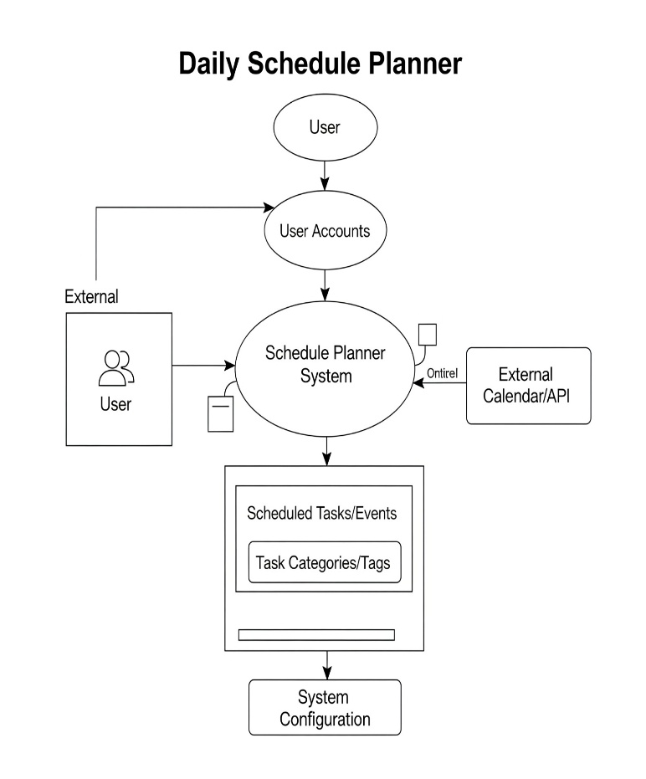

**Figure 1: DATA FLOW DIAGRAM – VOTING PROCESS**

## CHAPTER 4: IMPLEMENTATION

**MODULES & SCREENSHOTS**

**Module 1:** Date Selection & Daily Overview

Allows users to select a specific date to view or plan their schedule.

Displays the current day of the week based on the selected date.

(Screenshot: Refer to the Header section of the application, showing date input and current day display.)

**Module 2:** Fixed Schedule Management

Provides an interface to add, view, and delete recurring or fixed activities (e.g., Gym, College, Sleep).

Displays fixed activities with their start and end times.

**Module 3**: Daily Task Management

Enables users to add new tasks with a name, duration, and priority (High, Medium, Low).

Displays a list of all added daily tasks.

Allows deletion of individual tasks from the list.

**Module 4**: Dynamic Schedule Timeline

Generates and displays a complete daily schedule timeline, integrating fixed activities, allocated tasks, and identified free time slots.

Tasks are placed based on available time and priority, potentially splitting longer tasks.

Provides a visual representation of the day's plan.

**Module 5**: Personal Insights & Well-being

**Motivational Quotes:** Displays a random motivational quote to inspire users.

**Daily Notes**: A textarea for users to write down thoughts, goals, or reminders for the day.

**Mood Tracker:** Allows users to select their mood for the day and provides a corresponding message.

**Daily Statistics**: Shows key metrics like tasks added, total task time, high-priority tasks, free time, and productivity percentage.

**(iv) CODE & PROJECT SNIPPETS:**

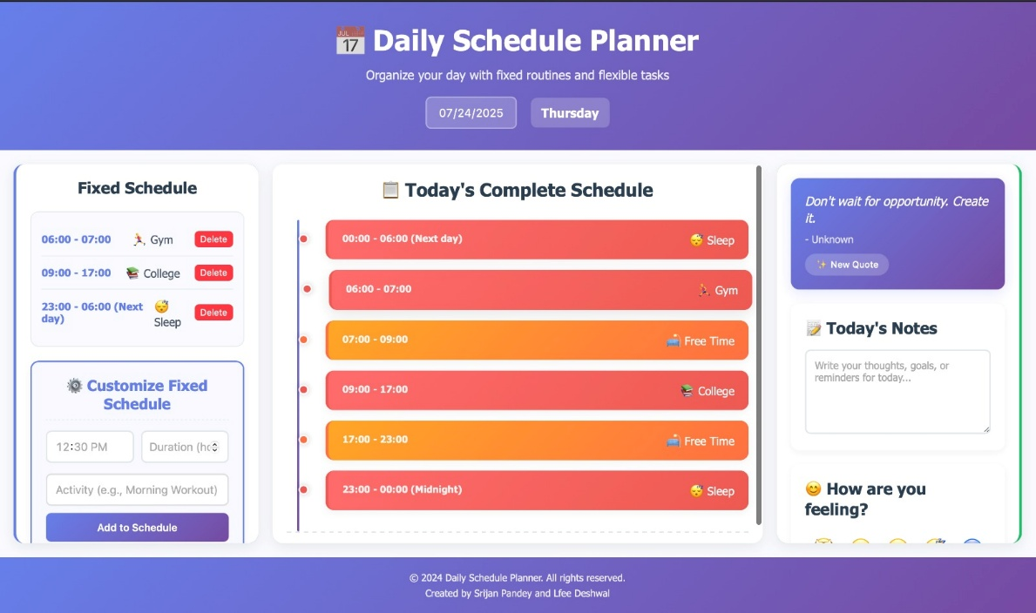

**Figure 1: HOMEPAGE – Daily Schedule planner**

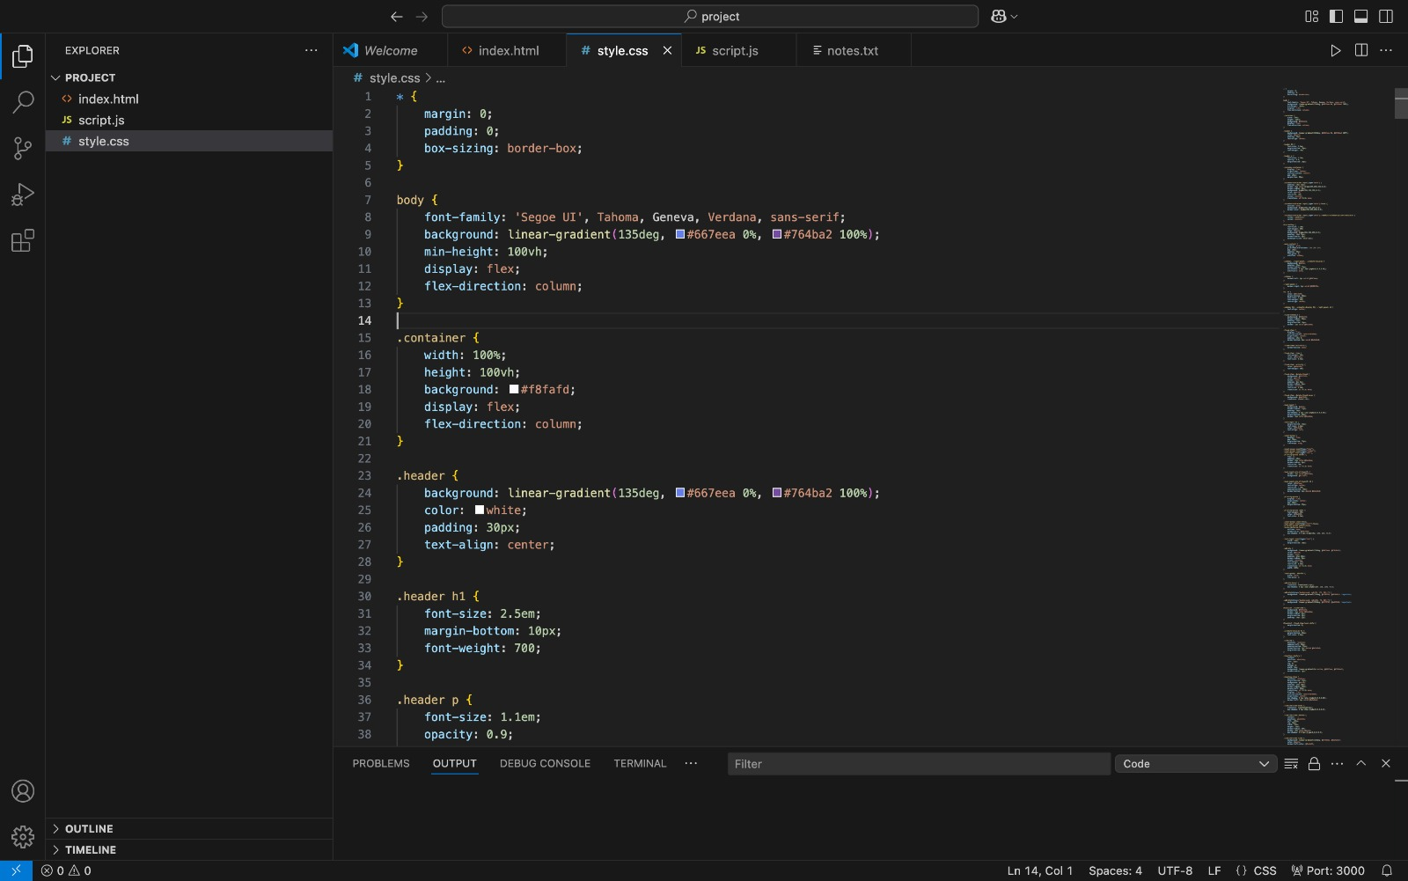

**Figure 2: CODE SNIPPETS**

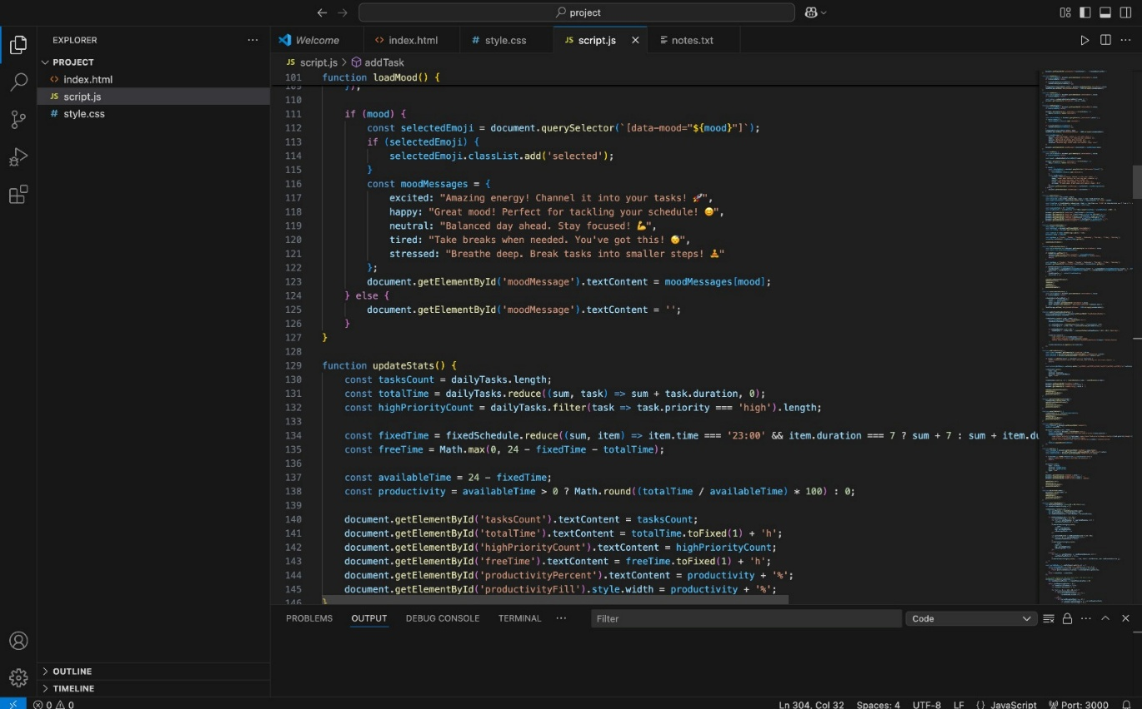

## CHAPTER 5: RESULTS AND DISCUSSION

**(i) OUTPUT**

**System Performance Metrics**:

The Daily Planner platform demonstrated efficient performance across all functional

requirements for a client-side application:

**Data Management Results:**

Daily data lookup (from localStorage object): Average < 0.01 seconds (O(1) average performance for object property access).

**Data saving to localStorage:** Near-instantaneous for typical daily data volumes.

**Data consistency:** Zero data corruption incidents observed during testing within browser sessions.

**Scheduling System Results**:

**Schedule generation time**: Average < 0.1 seconds for a full 24-hour schedule with multiple tasks and fixed activities.

**Task placement efficiency:** Tasks are prioritized and allocated effectively into available time slots.

**Real-time updates**: Schedule and statistics update immediately upon adding/editing/deleting items.

**User Experience Metrics:**

**Responsiveness:** Layout adapts seamlessly across various screen sizes (mobile, tablet, desktop).

**Intuitive Interface**: Users can easily navigate and interact with task inputs, schedule display, and personal insights sections.

**(ii) CHALLENGES FACED**

**Complex Scheduling Logic:** Designing the algorithm to dynamically fit tasks into fragmented free time slots, especially handling tasks that might span across multiple non-contiguous blocks, required careful planning and iteration.

**Local Storage Limitations:** While suitable for a single-user client-side application, managing data across multiple devices or for larger datasets would necessitate a backend database, which was outside the scope of this project.

**UI/UX Consistency:** Ensuring a consistent and visually appealing user experience across various components and responsive breakpoints required meticulous CSS styling and media query adjustments.

**State Management:** Managing the application's state (tasks, fixed schedule, notes, mood) and ensuring all UI elements reflect the current state efficiently, especially after data modifications, was a key challenge.

**Dynamic Content Updates:** Ensuring that the timeline, task lists, and statistics updated instantly and correctly after any user interaction (add, delete, date change) required robust event handling and re-rendering logic.

**(iii) TECHNICAL KNOWLEDGE GAINED:**

**Data Structures Mastery:** Gained practical understanding of how to effectively use JavaScript objects (acting as hash tables) for quick data access and arrays for sequential data storage in a client-side application.

**Algorithm Design Skills:** Developed proficiency in designing algorithms for time slot allocation, task prioritization, and dynamic schedule generation, focusing on efficiency within a browser environment.

**Problem-Solving Approach:** Developed a systematic approach to breaking down complex UI and logic problems into manageable, implementable components.

**Client-Side Data Persistence:** Gained hands-on experience with localStorage for simple and effective data persistence in web applications.

**Responsive Web Design:** Enhanced skills in creating adaptive user interfaces using CSS media queries and flexible box layouts to ensure optimal viewing on diverse devices.

**Event-Driven Programming:** Improved understanding and implementation of event listeners and handlers for interactive web applications.

**CHAPTER 6: CONCLUSION**

**(i) SUMMARY**

The summer training project “Daily Planner: Personal Productivity and Schedule Management System”

successfully demonstrated the practical application of Data Structures and

Algorithms in developing a comprehensive web-based personal productivity tool. The

project integrated theoretical DSA concepts with modern web development

technologies to create a functional, intuitive, and user-friendly daily planner.

**Key Achievements:**

**Effective Data Management**: The project effectively utilized JavaScript objects and arrays for efficient storage and retrieval of daily tasks, fixed schedules, notes, and mood data.

**Dynamic Schedule Generation**: Successfully implemented algorithms to dynamically generate a daily timeline, integrating fixed activities and prioritizing flexible tasks into available time slots.

**User-Centric Design**: Built a responsive frontend with a premium UI/UX design, incorporating motivational elements, notes, and mood tracking to enhance user engagement and well-being.

**Client-Side Persistence**: Implemented localStorage for reliable data persistence, allowing users to save and access their daily plans across browser sessions.

**TECHNICAL ACCOMPLISHMENTS:**

Implemented efficient data storage and retrieval mechanisms using JavaScript objects for daily entries.

Developed algorithms for dynamic schedule generation, including time slot allocation and task prioritization.

Utilized localStorage for seamless client-side data persistence.

Built a responsive frontend with a clear, intuitive, and aesthetically pleasing UI/UX design.

Integrated features for motivational quotes, daily notes, and mood tracking.

**LEARNING OUTCOMES:**

The project provided comprehensive understanding of:

Practical application of data structures (objects, arrays) in real-world client-side scenarios.

Algorithm design and implementation for scheduling and data processing.

Full-stack web development principles focusing on frontend logic and client-side data management.

UI/UX design principles and responsive web development.

Project planning and iterative software development lifecycle.

**(ii) PROJECT IMPACT**

This summer training project has significantly contributed to both technical skill development

and understanding of how computer science concepts apply to solving real-world problems.

The knowledge gained through implementing data structures and algorithms in a practical

context has provided valuable insights into software engineering best practices and system

design principles.

The successful completion of the Daily Planner demonstrates the ability to design, develop, and

deploy a functional personal productivity system while maintaining high standards of user experience and data integrity (within the client-side scope). The project serves as a strong foundation for future endeavors in

software development and computer science applications, particularly in the domain of web-based tools.

-------------------------------------------------- THE END --------------------------------------------------